StreetWatch – Message Router Design

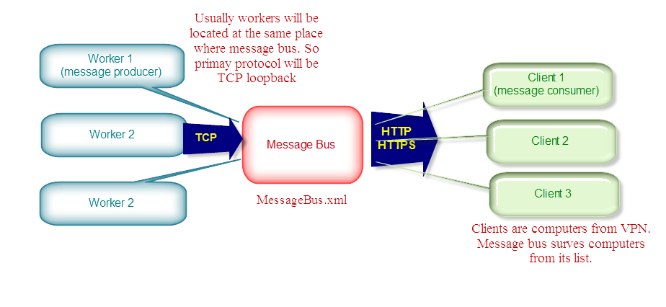

Content

Configuration 1

Logging 1

Libraries 1

Dependencies 1

# Configuration

**MessageBus.xml**

|  |
| --- |
| <?xml version="1.0" encoding="utf-16"?>  <configuration>  <messaging>  <producers>  <host="127.0.0.1" />  </producers>  <subscribers>  <host="127.0.0.1" />  </subscribers>  </messaging>  </configuration> |

# Logging

|  |
| --- |
| %temp%\HDE.StreetWatch\MessageBus\<DateTime>-PID.log  %temp%\HDE.StreetWatch\MessageBus\<DateTime>-PID-Security.log |

# Libraries

* BOOST

# Dependencies

None